Solder Void Impact on Power Module Thermal Impedance using Transient Thermal Analysis

Nathan Carlson
Department of Electrical and Computer Engineering
The University of Alabama
Tuscaloosa, USA
ncarlson@crimson.ua.edu
Nick Baker
Department of Electrical and Computer Engineering
The University of Alabama
Tuscaloosa, USA
nbaker2@ua.edu

Abstract— This research explores the relationship between die-attach solder voids and the thermal impedance of power modules. This is accomplished through an adapted transient system analysis technique. The analysis method aims to reduce the impact of extraneous variables while also taking into consideration the three-dimensional nature of heat flow in a power module. In addition, the degradation of the solder layer is also observed through power cycling. This method gives greater clarity into the thermal impact of voids.
Keywords—solder voids, thermal resistance, thermal impedance, structure function

Introduction
One of the main methods of void removal is the use of a vacuum or pressurized soldering oven. However, for cost-sensitive applications or low-volume production, these machines can significantly drive up the cost of production. Therefore, it is necessary to accurately quantify the impact of voids on the thermal performance and reliability of power modules. An accurate knowledge of the effects of voids will allow for upgraded decision-making capability when designing solder processes.
To address this issue, the relationship between the voids and the thermal impedance of the module must be measured. However, one difficulty in this measurement process is the variance in thermal impedance caused by other layers in the power module, such as the heatsink interface. These unwanted effects introduce significant errors to steady-state thermal resistance measurements. Because of this issue, the thermal impedance impact of the solder layer is measured shortly after applying a heating current to the device. This is often described as a transient thermal measurement, and it aims to select a point in time where there is significant heat flux through the solder layer, but minimal flux through the lower layers.
Several authors have examined voids through thermal transient measurements using both finite element means [1][2][3] as well as through experimental measurements [4][5][6]. However, many sources analyze the solder layer using the structure function method, first introduced in [7]. One of the major shortcomings of the structure function method is that it assumes a 1-D Cauer network heat flow model. This assumption does not account for the effect of thermal spreading. Li et al. showed in [2] that there are significant differences between the behavior predicted by the traditional Cauer network and a 3-D simulation of a voided power module.
This work seeks to improve upon this issue through the use of a thermal transient interpretation which does not rely upon a 1-D assumption of heat flow.

Experimental Procedure

Sample Module Construction
For this experiment, 25 sample modules consisting of a single power diode rated at 600V and 50A (VS-4FD198H06A6BC) were constructed (Fig. 1). Each module was soldered using a lead-free SAC305 solder paste. The solder paste was acquired from two different manufacturers in order to reduce bias from a single paste type. The Manncorp MC 301 convection reflow oven was used, and three separate temperature profiles were employed in order to produce modules with both low and high void amounts.
An additional techniquie first introduced in [8] was also employed for 5 samples. This manufacturing method involves reflowing the die-attach solder without the chip mounted, then placing four small balls of solder paste on the corners of the mounting area and placing the chip, and then reflowing the device for a second time. This was done in order to obtain samples with a lowered void count, as well as to provide a second point of comparison for the results obtained in [8].
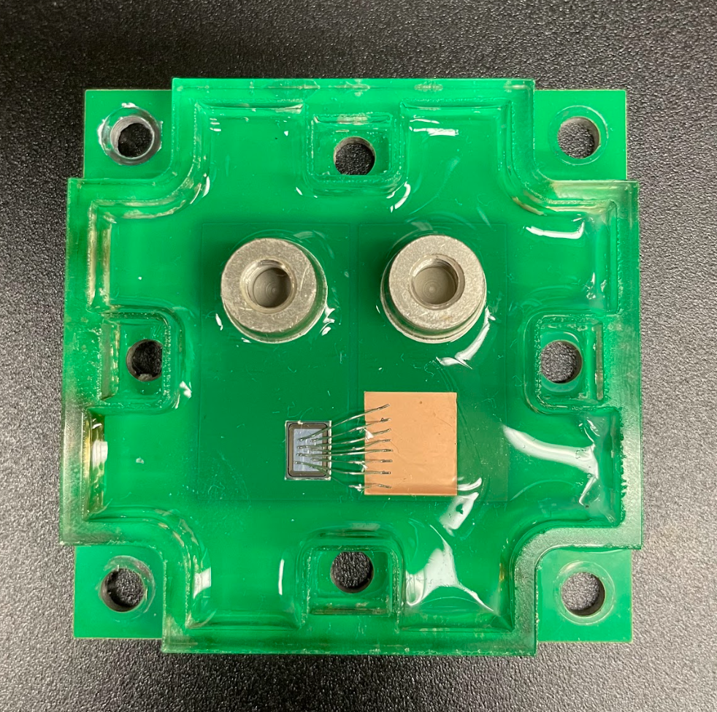
Fig. 1. Construction of the single-diode module.
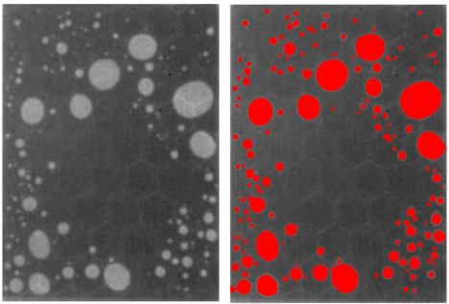
Fig. 2. Raw x-ray image of solder layer (left) and processed image (right).
After the reflow process, the voids were imaged (Fig. 2) using the Glenbrook RTX-113 HV x-ray machine. In order to accurately map the voided areas of the solder layer and calculate the void percentage, the x-ray images were processed in Photoshop using the fill tool as a method to selectively highlight the voided areas. The “contiguous” mode was used on the fill tool, and the following threshold setting were used: 35, 27, 20, 13, 5. Higher thresholds were used for large voids with sharply contrasted edges. The variance due to manual processing was also measured, with an average percent error of 5.6% for the fill tool method. This error metric was tested by re-processing four of the x-ray images several days after their initial completion, and comparing the void ratio to the original copies. The images were then cropped to include only the solder layer, and then a Python script was used to calculate the percentage of highlighted pixels.
The topside connections of the modules were made using either eight 250 μm diameter wire bonds or six 300 μm diameter wire bonds. Finally, a fiberglass enclosure was attached to the module using tacky glue, and the device was enclosed using silicone rubber.

Thermal Transient Test
For this test, the main temperature sensing method used was the forward voltage drop of the diode at I_{f} = 50 mA. For calibration, this voltage was measured across several diodes from 15°C to 90°C. During the calibration, a thermocouple was used to measure the temperature of the diode. From these measurements, a second-order polynomial fit was generated for the forward voltage relation with temperature.
Next, the samples were secured to a cold plate with a graphite film as the thermal interface material, and a heating current was applied for a duration of 200 seconds. Each module was tested with a heating current of 5, 10, 15, 20, 22, and 24 A. After the heating current was disabled, a sensing current was applied, and the junction temperature was measured at logarithmically spaced time intervals from 200 μs to 200 s. The data before 200 μs was not included due to electrical transient effects of the diode, and instead data was fitted to this region through the assumption that the temperature is approximately linear with the square root of time during this period.

Mathematical Analysis
The first step of the analysis was the transformation from the cooling curve data to the equivalent heating curve. This requires the assumption that the thermal system is linear and time-invariant (LTI). The property of linearity approximately holds in this case, as the total change in the thermal impedance from the 5A test to the 24A test was always less than 10% for all modules and all sampling times. Time-invariance also holds because the thermal system does not undergo any substantial change during the thermal testing procedure. Insert how transformation works
Next, the time constant spectrum (TCS) was calculated using the T3ster Master software, which uses the method outlined by V. Széleky in [7]. This is the first step of the calculation of the structure function, however the TCS does not require the assumption of a 1-D model of heat flow, and so can be used with greater validity. The TCS describes how the system responds to the heating current in terms of a sum of exponential terms. Peaks in the TCS roughly correspond to points in time where the heat flux reaches a layer with higher thermal impedance. The first peak in Fig. 3 corresponds to the thermal response of the solder layer. Notably, the heat flux does not pass through a layer uniformly as would be the case in 1-D heat flow. This is likely one of the reasons why the peaks are not single points but are rounded in nature. These peaks were detected using the detect_peaks() function from the Scipy.signal library in Python. A prominence of 0.003 was used along with the requirement that all peaks had to be greater than the nearest n neighbors, where n is equal to 1/20th of the total size of the dataset.
In order to most precisely measure the thermal impedance of the solder layer, the optimal time of sampling should occur at some point after the first peak. This is because at exactly one time constant, the heat flux through the solder layer is still well below its maximum value, and so the measurement will be more sensitive to noise. Instead, the measurement should more accurately be taken in the range of 3-5 multiples of the time constant. At this point, the heat flux will be near its steady-state value in the solder layer, while still not fully conducting through the lower unwanted layers.
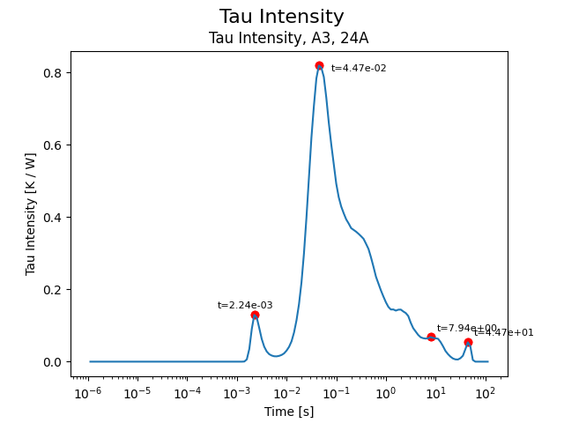
Fig. 3. Time constant spectrum (TCS) with peaks identified.
In order to pin down exactly when the thermal impedance should be measured, the derivative of the cooling curves are used. This method is an adapted version of a technique presented in [9]. The idea of this method is that, if the solder layer were to have any effect on the thermal impedance of the module, then there would be some noticeable region in time where the impedance curves deviate from each other. In order to further observe where this deviation occurs, the time-derivative is taken. In addition, the derivatives are also normalized with respect to the average of the signals in order to allow improved observation of the deviation. The results of this process is pictured in Fig. 4.
As shown in Fig. 4, the curves begin to significantly deviate around the 1-2 ms mark, matching the previous analysis from the time constant spectrum plot. Thus, in order to get a full picture of the total thermal impedance of the solder layer, the sampling should occur when the graphs re-converge at approximately 10 ms. The convergence of the graphs indicates that the heat flux has nearly reached its steady-state value within the solder layer but has not yet fully reached the other sources of thermal variance such as the cold plate interface.
In combination, the TCS and the derivative deviation paint a clear picture of what time the solder layer is able to be measured most accurately. Neither of these methods rely on a 1-D assumption of heat flow, and so they are more broadly applicable to

Results
First, the choice of the time when the solder curves deviate is necessary. This was mainly accomplished through the use of the TCS. Fig. 4 is a cumulative total of all of the detected peaks for all 25 modules. From this measure, it can be seen that there is a prominent cluster of peaks at about 2.5 ms. This peak can also be seen in Fig. 3. This first peak corresponds to the first thermal interface that the heat flow encounters, which is the solder layer.
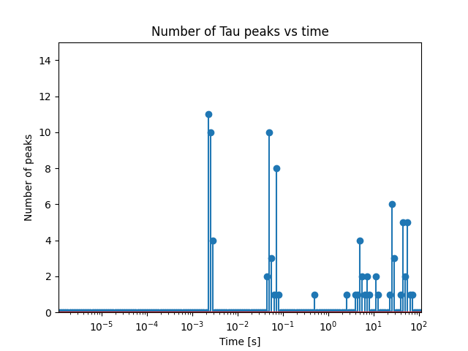
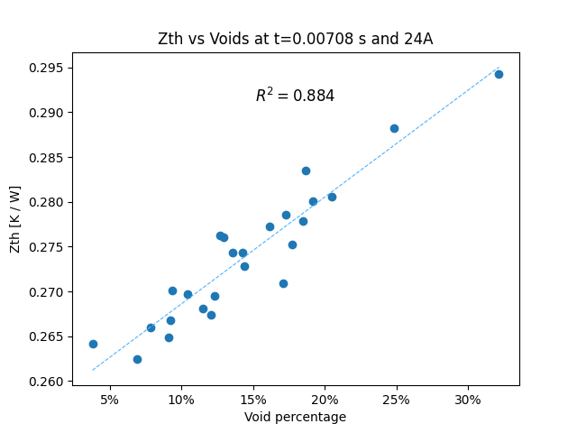
Figure 5. Thermal impedance vs void percentage at 7 ms.
Next, the relationship between the thermal impedance and the void percentage was analyzed as shown in Fig. 5. The time of the thermal impedance measurement was taken at a value of about three time constants away from the response of the solder layer, however any time sample between 2.5 ms and 10 ms shows a similar pattern.

Conclusion
X

Acknowledgments
x

References

- P. Xu, P. Liu, L. Yan, and Z. Zhang, “Effect of Solder Layer Void Damage on the Temperature of IGBT Modules,” Micromachines (Basel), vol. 14, no. 7, Jul. 2023, doi: 10.3390/mi14071344.J. Clerk Maxwell, A Treatise on Electricity and Magnetism, 3rd ed., vol. 2. Oxford: Clarendon, 1892, pp.68–73.
- Q. Li, F. Zhang, Y. Chen, T. Fu, and Z. Zheng, “A junction temperature model based on heat flow distribution in an IGBT module with solder layer voids,” Heliyon, vol. 10, no. 13, Jul. 2024, doi: 10.1016/j.heliyon.2024.e33625.
- K. Fladischer, L. Mitterhuber, E. Kraker, D. Ginter, J. Rosc, and J. Magnien, “A Close Look on Voids in Solder Joints,” in 24th International Workshop on Thermal Investigations of ICs and Systems, Stockholm: Therminic, Sep. 2018.
- S. Singh et al., “Effects of die-attach voids on the thermal impedance of power electronic packages,” IEEE Trans Compon Packaging Manuf Technol, vol. 7, no. 10, pp. 1608–1616, Oct. 2017, doi: 10.1109/TCPMT.2017.2742467.
- D. C. Katsis and Jacobus Daniel vanWyk, “A Thermal, Mechanical, and Electrical Study of Voiding in the Solder Die-Attach of Power MOSFETs,” IEEE Transactions on Components and Packaging Technologies, vol. 29, no. 1, pp. 3–4, Mar. 2006, doi: 10.1109/TCAPT.2006.
- L. Ciampolini, M. Ciappa, P. Malberti, P. Regli, and W. Fichtner, “Modelling thermal effects of large contiguous voids in solder joints,” Microelectronics J, vol. 30, pp. 1115–1123, 1999, [Online]. Available: www.elsevier.com/locate/mejo
- V. Székely and T. Van Bien, “FINE STRUCTURE OF HEAT FLOW PATH IN SEMICONDUCTOR DEVICES: A MEASUREMENT AND IDENTIFICATION METHOD,” Solid State Electron, vol. 31, no. 9, pp. 1363–1368, 1988.
- J. Yang, "Study on solder void for PiP large solder area ultrathin die in solder reflow," in 2019 20th International Conference on Electronic Packaging Technology(ICEPT), Hong Kong, China, 2019.
- D. Schweitzer, H. Pape, and L. Chen, “Transient Measurement of the Junction-To-Case Thermal Resistance Using Structure Functions: Chances and Limits,” in 2008 Twenty-fourth Annual IEEE Semiconductor Thermal Measurement and Management Symposium, San Jose: IEEE Xplore, 2008, pp. 191–197.
- X
- x
- x

Fig. 4. Cumulative total number of peaks across all samples vs time.

